Transport in Vascular Plants
Ch 36

Review:
Membrane selectively
Passive transport:
Transport protein:
Facilitated diffusion:
Active transport:
Chemiosmosis:
Overview of transport: Fig 36.2
Proton pump:
Membrane potential:
Cotransport
(Fig 36.4)
Water potential:
Osmosis:
Water potential:
Solute potential:
Pressure potential:
(Fig 36.5) & (Fig 36.6)
Plasmolysis:
Turgor pressure:
Aquaproin protein:
Vacuolated plant cells: (Fig 36.8 a)
Central vacuole:
Tonoplast:
Symplast:
Plasmodesmata:
Apoplast:
Transport over short distance: (Fig 36.8 b)
Transmembrane route:
Apoplastic route:
Symplastic route:
Long distance transport: (Fig 36.2)
Bulk flow:
Absorption of water & minerals:
(Fig 36.9)
Epidermal cells
Mycorrhizal fungi:
Endodermis:
Casparian strip:

Roots to Leaves:

Transpiration:
Guttation:
Transpiration-Cohesion-Tension Mechanism
(Fig 36.12)
Cohesion / Adhesion
(Fig 36.13)
Cohesion:
Adhesion:
Stomata:
Gas exchange:
Control water loss:
(Fig 36.15)
Guard cells:
Stimuli to open stomata
Movement of Sugar:
Phloem sap:
Sugar source:
Sugar sink:
Direction of flow in phloem
(Fig 36.18)
(Fig 36.19)

Plant cell - plasmodesmata

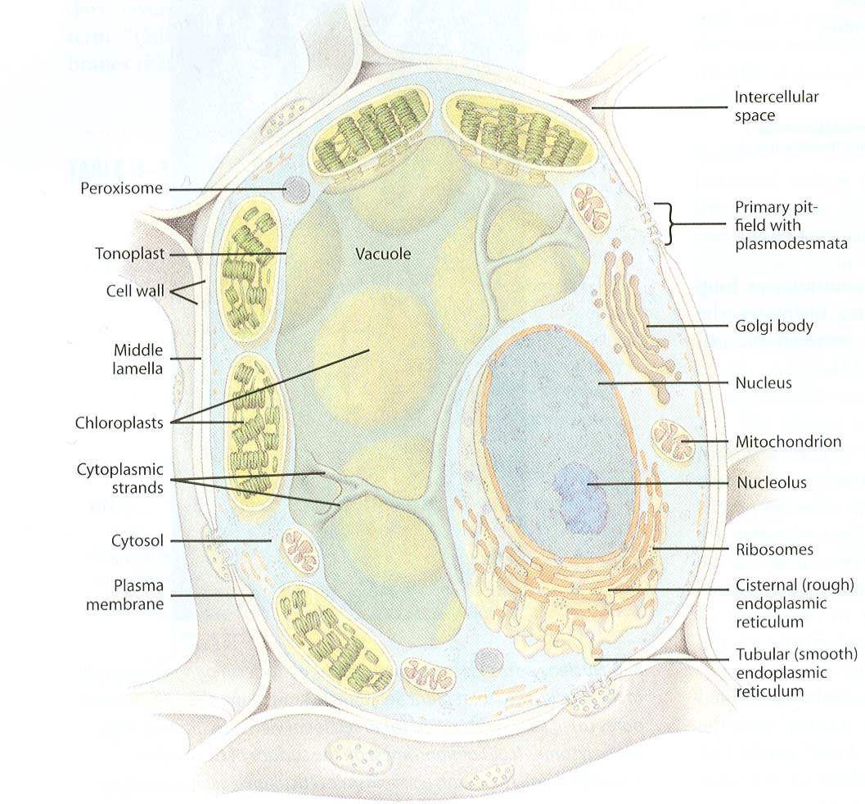

Plasmodesmata

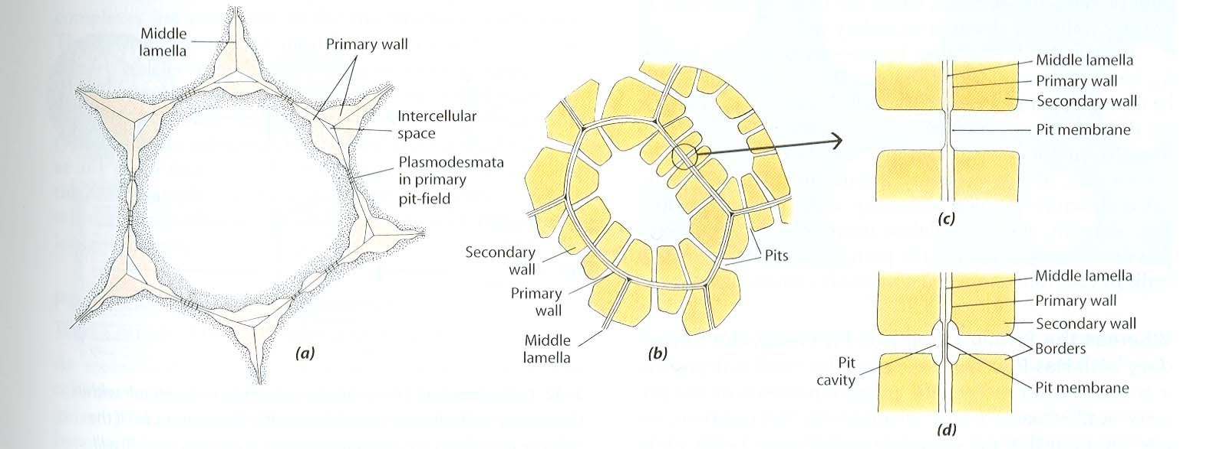

Plasmodesmata

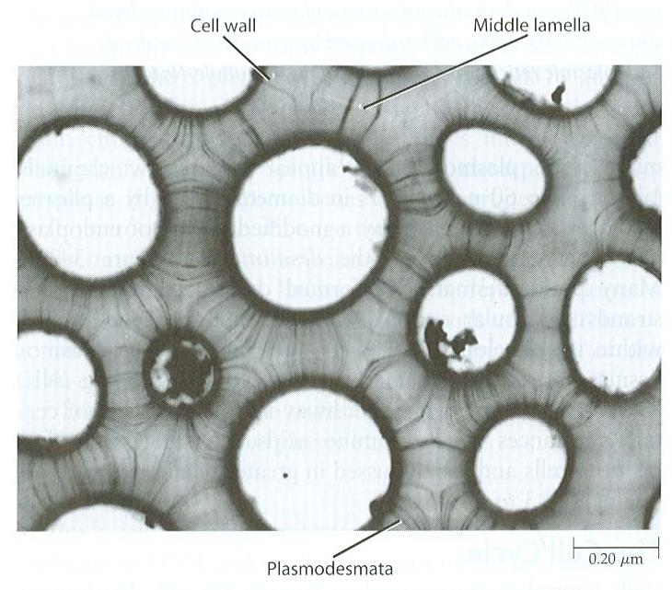

Water transport into the root.
